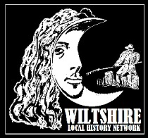
Wiltshire Local History Network
Are you an individual or group interested in Wiltshire’s history?
The Wiltshire Local History Network aims to provide a welcoming connection, to meet and engage with others who have a shared interest in the history of our county, to share knowledge and provide a valuable point of contact. You’ll also hear all about what’s going on in the county’s heritage organisations such as the Wiltshire & Swindon History Centre, Wiltshire Victoria County History, Wiltshire Museum and more.
We meet four times a year online via Zoom on a Wednesday evening at 7.30pm
Why not join us? Membership is free and also includes a free place at our upcoming conference on Saturday 23 September at Rowdefield Farm Training Centre ‘Bread or Blood: Social Protest and Unrest in Wiltshire’.
Contact the Wiltshire & Swindon History Centre via archives@wiltshire.gov.uk or tel. 01249 70550 to join the Network or to find out more.

Wiltshire now has a new and updated online portal for anyone interested in the county’s history
You will discover historical information for the 261 communities covering the Wiltshire Council administered area on the Wiltshire Community History website. There is a general history of each parish with further information on schools and churches. Maps, details about local authors, literary and creative associations in the county can also be found, alongside a large number of photographs, to help you discover just what makes each community unique.
To help, each community also contains administrative information such as the most useful newspapers for research, population statistics and a list of sources in the Local Studies Library at the Wiltshire & Swindon History Centre.
You can access the site via the link Community History (wiltshire.gov.uk)
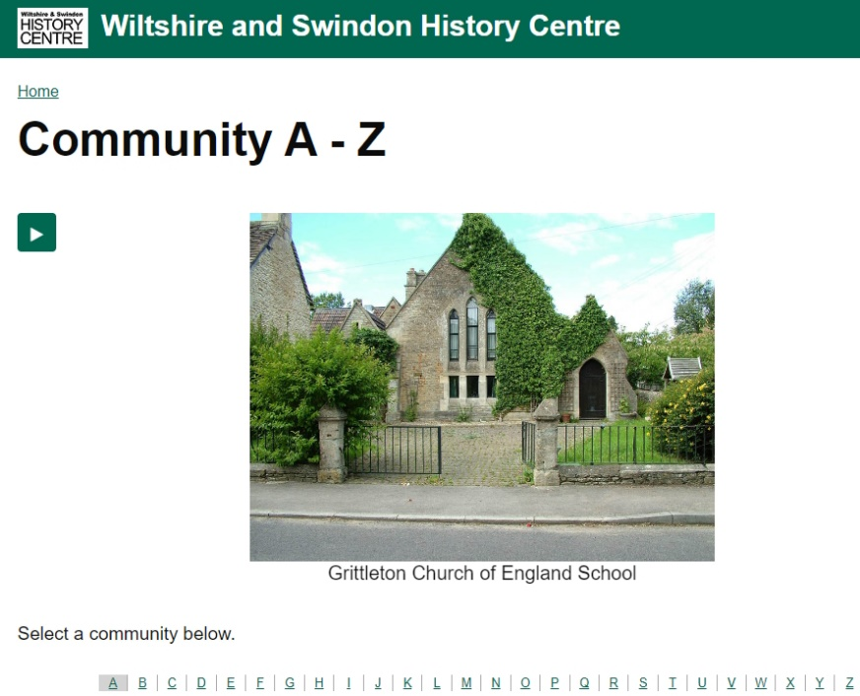

VCH Wiltshire
The Wiltshire Victoria County History Trust continues to progress work on its multi-volume comprehensive history of the county. With 18 out of an eventual 25 volumes already published, Volumes 19 (covering the area around Mere) and 20 (covering Chippenham and its surroundings) are both close to completion, and Volume 21, covering Alderbury and the far south east of the county, is under way. Read all about the work on their website - https://www.wiltshirehistory.org/ - which also gives details of this year's programme of online talks. The website also offers access to current and past volumes online.

